1. The staff in the HR department wants to hide some of the data in the EMPLOYEES table.

They want a view called EMPLOYEES_VU based on the employee numbers, employee

names, and department numbers from the EMPLOYEES table. They want the heading for

the employee name to be EMPLOYEE.

1. Confirm that the view works. Display the contents of the EMPLOYEES_VU view.

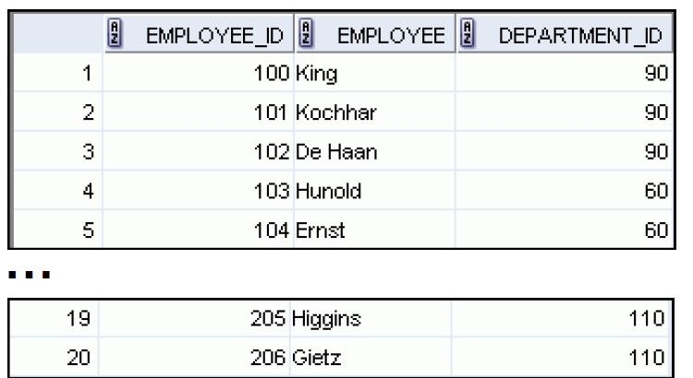

1. Using your EMPLOYEES_VU view, write a query for the HR department to display all employee names and department numbers.
2. Department 50 needs access to its employee data. Create a view named DEPT50 that contains the employee numbers, employee last names, and department numbers for all employees in department 50. You have been asked to label the view columns EMPNO, EMPLOYEE, and DEPTNO. For security purposes, do not allow an employee to be reassigned to another department through the view.
3. Test your view. Attempt to reassign Matos to department 80.

PART II

1. You need a sequence that can be used with the PRIMARY KEY column of the DEPT table. The sequence should start at 200 and have a maximum value of 1,000. Have your sequence increment by 10. Name the sequence DEPT_ID_SEQ.
2. Create a table “Depts” that has 2 columns. Dept_id (int, primary key) and dept name (text, not null).
3. Insert 3 rows to your table. The names of the departments should be: research, development, r&d. for the id numbers- use your sequence.

--if you have time:

1. Open another session and open a transaction there.
2. Use your sequence once in a select statement
3. Rollback the transaction.
4. Go back to the original session and enter a 4th department, named “a-counting” using your sequence., what is the department’s number?